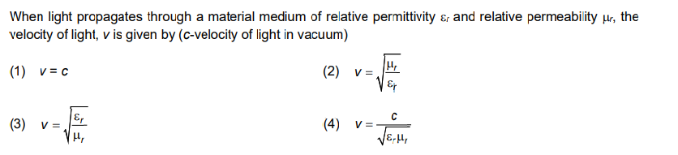NEET QUESTIONS

2. The dimensions [MLT–2A–2] belong to the

(A) Magnetic flux (B) Self -inductance (C) Magnetic permeability (D) Electric permittivity

3. Plane angle and solid angle have (A) Units but no dimensions (B) Dimensions but no units

(C) No units and no dimensions (D) Both units and dimensions

4.